Deliverable #4 - Usability Project Final Report

INLS 690-172 - Fall 2013

December 7th, 2013

Lifetime Library Liberators

LLL

Mandi Gonzalez, Michael Head, Erin Holmes, Mrudula Sudarsanam

Lifetime Library

Table of Contents

Executive Summary 4

Overview 5

Purpose of the Usability Evaluation 5

Usability Evaluation Goals 6

User Profiles and Use Cases 6

Method 6

Participants 6

Equipment and Materials 7

Task List and Descriptions 7

Procedure 9

Roles of Team Members 9

Moderator: 9

Technical Support: 10

Scribe: 10

Data Collection 10

Evaluation Measures 11

Results 12

Task A: Logging in 12

Task Success 12

System Errors 12

Confidence and Level of Difficulty 12

Perceived Use of Time 12

Comparative Ease of Use 13

Task B: Uploading a file 13

Task Success 13

System Errors 13

Confidence and Level of Difficulty 13

Perceived Use of Time 14

Comparative Ease of Use 14

Task C: Adding metadata 14

Task Success 14

System Errors 14

Confidence and Level of Difficulty 15

Perceived Use of Time 15

Comparative Ease of Use 15

Predicted Use 16

Task D: Sharing a file 16

Task Success 16

System Errors 16

Confidence and Level of Difficulty 17

Lifetime Library Usability Scale 19

Task Totals 20

Summary of Results 21

Recommendations 22

Labelling 22

Design 23

System Status 24

Reflection 25

Appendix A: Moderator Guide 26

Pre-Session Instructions 26

For Moderator: 26

Moderator Session Script 26

Task A: Log into the SILS Lifetime Library 30

Task B: Add a file to your account 31

Task C: Describe a file 32

Task D: Give a user permission to view, but not modify, your file. 33

Appendix B: Informed Consent Form 34

Appendix C: Questionnaires 37

1: Pre-Test Questionnaire 37

2: Task A Post Questionnaire 38

3: Task B Post Questionnaire 39

4: Task C Post Questionnaire 40

5: Task D Post Questionnaire 42

6: Lifetime Library Usability Scale 44

# Executive Summary

We conducted a lab-based usability test of the Lifetime Library website, between the 21st and 25th of November 2013. The Lifetime Library is a cloud-storage service that is currently offered to SILS students and alumni. Four participants were asked to perform a set of tasks that were representative of the major features offered by the Lifetime Library. We designed the test based on the results of a cognitive walkthrough of the website to assess the usability of the website in:

* Logging in
* Uploading a file
* Adding Metadata to a file
* Sharing a file with another user

Data was collected through pre-session, post-task and post-session questionnaires. This data was supplemented by comments made by the participant as they thought aloud and a post-session interview.

**Task Performance**

All participants were able to complete tasks A and B successfully. All participants had some trouble with task C. Three out of 4 participants completed the tasks on their own, one participant gave up and was assisted by the moderator to complete the task. All participants struggled with task D as well. Three out of 4 participants did not complete the task.

**Summary of Findings**

The participants found the website to be appealing, with a clean & modern feel to it. The first two tasks were completed by the participants with fair ease, but they commented about how the labelling was inconsistent in the website. Three of the 4 participants successfully completed task C but they commented about the vocabulary and were unsure about what ‘Unit’ was. One participant gave up, but was able to complete the task with the moderator’s assistance. Sharing a file was found to be an unnecessarily complex process; all participants had some trouble with accomplishing this task. While all of them thought that they had successfully completed the task, only one of them completed the task.

**Summary of Recommendations**

Based on the results of the usability evaluation detailed in this document, we have a few suggestions for improving the usability of the website which are listed below:

* More Consistent Labelling
* Improve Design
* Better notification of System Status

# Overview

The Lifetime Library at UNC is a website and desktop application designed to provide students with access to “grid data storage”, otherwise known as “cloud storage.” The goal of the system is to provide students and alums “trusted storage for their entire lives.”[1] The website consists of pages for creating an account, logging in, uploading files, adding metadata to files, searching, and sharing files.

The Lifetime Library consists of a web interface and a desktop client. We focused on the website interface exclusively in order to maintain focus on one part of the user experience. The website is accessible (with an account or as a guest) at <https://lifetime-library.ils.unc.edu/idrop-web2/login/login>.

The system was chosen because it is a fairly complex system, comparable to industry applications such as Google Drive and Dropbox in its feature set, and it is maintained by SILS, in collaboration with RENCI and other UNC groups. As SILS students ourselves, we performed a usability evaluation that we hope will be useful in improving the user experience for other SILS students, and eventually all of UNC if the system is opened to everyone else.

# Purpose of the Usability Evaluation

Per the website’s project profile, the aim of the Lifetime Library is “to provide trustworthy and easy to use services.”1 In order for the Lifetime Library to achieve its goal of being easy to use, its users must be able to effectively and efficiently perform essential functions within the system, including logging in, uploading a file, sharing a file, and adding metadata to a file. In the cognitive walkthrough we performed, and through heuristic analysis, we discovered some usability errors with the aforementioned functions, such as inconsistent labeling. The purpose of our usability evaluation was to test the usability of these essential functions with users of the Lifetime Library to gauge how well the website did in providing easy to use services.

Currently only UNC SILS students are eligible for accounts with the Lifetime Library. An improved user experience will hopefully encourage more SILS students to use the site and possibly encourage the system administrators to expand the service to the rest of the general student body population at UNC-Chapel Hill. UNC SILS students may be more comfortable with technology than other parts of the UNC population. As the service grows to allow other users outside of SILS, users who may not be as comfortable with technology, ease of use of the system will be even more important.

Also, because there are many other products available that have comparable features, SILS students have many options for cloud storage and sharing files. With so many other options, students may choose a cloud storage service other than the Lifetime Library, which would hurt its rate of adoption. Having performed a usability evaluation on the Lifetime Library, we provide recommendations in this report for improving the system so it can better compete for users’ time with these other products.

# 

# Usability Evaluation Goals

Our evaluation goal was to measure how intuitive users found four of the features of the system: logging in, uploading a file, adding metadata to a file, and sharing a file. For each particular feature, we measured if a first time user was able to complete specific tasks related to that feature successfully and easily. We addressed the following questions in our usability evaluation:

* Is it clear to first-time users how to login when their account is first created?
* Is the file upload process easy to use and efficient?
* Are users able to figure out how to add metadata to a file?
* Can users successfully share a file with another user?

# User Profiles and Use Cases

Since one of the aims of the Lifetime Library is to provide trusted storage to SILS alumni and students for their entire lives, we focused on current SILS students in our usability evaluation. It may be worthwhile for future usability studies to focus on alumni.

The 4 participants in the evaluation were all female, 18-29, with some experience with similar file sharing services, such as Dropbox. Only one participant reported having previous experience with the Lifetime Library. All 4 participants had experience with Google Drive, while 3 participants had experience with Dropbox.

We focused on use cases that represent the major features in the Lifetime Library

The use cases that we tested were:

* A new user logging into her account for the first time.
* A new user uploading a file for the first time.
* A new user adding metadata to a file.
* A new user adding read-only permission to a file for another user.

# Method

## Participants

There were 4 participants who took part in this usability evaluation. The participants were SILS students, who had minimal or no previous experience using the Lifetime Library. Only one participant reported having previous experience with Lifetime Library, having signed up for the service a year ago but never having accessed the Lifetime Library account since then. As current SILS students, these participants were representative of one of the target demographic groups of Lifetime Library users. The participants were provided with a set of task scenarios that represent the features of the Lifetime Library that we wanted to evaluate. The participants were asked to complete these tasks as efficiently as possible. Once they completed a task, they were asked to provide feedback regarding the process and the usability of the Lifetime Library through post-task and post-session questionnaires.

**Test Environment**

This usability evaluation was conducted in Room 9 of the Interactive Information Systems Lab (IISL). We used a computer system equipped with Camtasia that recorded the screen and audio of the participants. For all the evaluations there were three people present in the room during the evaluation - the participant, the moderator, and the scribe. If schedules permitted, we were allowed the luxury of having a dedicated technical support person in the room, but otherwise the scribe doubled as the technical support person when needed. The participant’s interaction with the system was monitored by the moderator. The scribe took note of the participant’s comments as well as any other relevant pieces of information as participant completed the tasks. The Camtasia recording was used to monitor time. The scribe kept time independently to ensure that the participants finished the sessions in the allotted hour. We did face a couple of technical issues during the evaluation, but there was a dedicated technical support specialist on both these occasions who worked to resolve these issues.

## Equipment and Materials

The study was conducted in Room 9 of the IISL. Of the computers in the room, the one closest to the door was used for the study. That computer was equipped with Camtasia and a microphone which was used for screen and audio capture. The comprehensive list of materials we used during the course of the evaluation is below:

* Computer with internet access
* Camtasia screen and audio capture software
* Microphone
* Flash drive encrypted with TrueCrypt to store each session results
* Laptop with a TrueCrypt partition for the scribe to take notes
* Notepad
* Pencils and pens
* Copy of the moderator guide
* Copies of the tasks
* Copies of the questionnaires

We also used a Lifetime Library test user profile that was created specifically for this evaluation. We provided the participants with these login credentials to access the Lifetime Library and complete the tasks.

## Task List and Descriptions

Participants were asked to complete a sequence of four simple tasks. We chose these tasks because they were representative of the major features that are offered by the Lifetime Library. All four participants were provided the same set of tasks. These tasks test the system on the ease of logging in and accessing the Lifetime Library system, uploading a file to the Lifetime Library as well as annotating this file and sharing it with another user. The participants used the test account to complete these tasks. For the login task, the user began from the home page rather than the account creation email. This is mainly because the account creation email does not have a link to the Lifetime Library homepage. It contains only a link to the Lifetime Library video tutorial page. The tasks scenarios are as described below and their respective post-questionnaires are listed in Appendix B. Short names are provided for more easily referencing a task later in the report.

Task A: A new user logging into her account for the first time.

Scenario: The user has just received her login credentials and would like to use these credentials to login to the Lifetime Library. The username provided to the user is ‘test_user_eval’ and the password for this user is ‘userevaluation’.

Short name: *Logging in*

Task B: A new user uploading a file for the first time.

Scenario: Once the user has logged into Lifetime Library, she would like to use the facility to upload a file. The file is called oldwell.jpg and is available on the desktop. This file should be uploaded into the user’s profile/account on Lifetime Library.

Short name: *Uploading a file*

Task C: A new user annotating a file (adding metadata).

Scenario: The user has uploaded the file ‘oldwell.jpg’ into her Lifetime Library Account, and now wishes to add more details to this file that will help her identify it. The user should annotate the file to indicate that the photo was taken using the iPhone camera.

Short name: *Adding metadata*

Task D: A new user adding share permissions to a file.

Scenario: The user wishes to share the file - ‘oldwell.jpg’ that she uploaded in Task C, with another user who has a Lifetime Library account. This file will be available in the UPLOADS folder (after the completion of Task C). The user should share this file with user Jane Doe whose user id is *‘erholmes’.* The user should provide only READ permissions for this file to user Jane Doe.

Short name: *Sharing a file*

These tasks describe some of the central features of the Lifetime Library. Through our cognitive walkthrough we found several usability issues with each of these tasks and wanted to evaluate them with actual users in order to identify the usability issues that users encounter.

## 

## Procedure

Prior to the evaluation, we coordinated with the participants to schedule a time for the evaluation. We checked with Anita to make sure that room 9 of the IISL was available for the scheduled time and booked it for the evaluation.

Below is a small summary of the general sequence of events that occurred during the evaluation:

1. Set-up the computer in room 9

a. Logged in

b. Added the Lifetime Library to the favorites/bookmarks tab in Mozilla Firefox, Internet Explorer and Google Chrome and clear cookies

c. Started Camtasia, and set up a new project

d. Made sure microphone was turned ON

2. Received the participant

3. Welcomed the participant

a. Introduced other team members

b. Went over purpose of evaluation, introduced think aloud

c. Provided consent form for participant to sign

d. Asked if participant had any questions

4. Provided pre-test questionnaire

5. Began Camtasia screen capture and audio recording

6. Asked participant to use preferred browser to access Lifetime Library and asked them about their initial thoughts

7. Provided usability task descriptions and asked participant to complete tasks and reminded them to think aloud

8. Asked participant to complete post-task questionnaire

9. After all the tasks were completed, asked participant to complete post-session questionnaire.

10. Conducted post-session interview

11. Asked if the participant had any questions

12. Ended Camtasia recording

13. Thanked participant for taking part in the evaluation

14. Ended session

# Roles of Team Members

We defined roles for the usability test as follows. The roles were rotated per participant in order to give everyone experience with every role.

## Moderator:

* Welcomed the participant.
* Provided an overview of the usability study to the participant.
* Provided assistance to the participant during the test, when requested.
* Provided the pre-test, post-task and post-session questionnaires to the participant.
* Conducted the post-session interview.

## Technical Support:

This role was defined to take care of any technical issues during the evaluation. When schedules permitted there was a dedicated technical support specialist for the evaluation. We had a technical support specialist for two out of our four evaluation sessions. In the other two sessions, the scribe took up the responsibilities of the technical support specialist.

* Set up the test environment before each session (including clearing cookies and setting up Camtasia for screen and audio recordings).
* Followed up with the correct people when the service went down to ensure that it was running for the other evaluations.
* Resolved other technical issues that occurred during the test.

## Scribe:

The scribe observed the usability test, participant’s interaction with the interface, and took notes about the participant’s actions and comments. The scribe recorded think aloud speech and notable quotes from each participant. When there was no dedicated technical support specialist, the scribe set up the test environment before the beginning of the test and resolved any technical issues during the test.

# Data Collection

We recorded audio of users and their screens during each test session with Camtasia with the users’ consent. The recordings were saved to the computer, transferred to an encrypted USB key, and then deleted from the computer. We named each recording file using participant numbers (in the order they came in to take the studies), and did not include any personally identifiable information in the file names. During each session we collected the amount of system errors per task, participant. The scribe took notes on the laptop, which were saved in a file in an encrypted partition. The following paper-based questionnaires were administered throughout each session:

* Pre-test questionnaire to gather demographic data and gauge familiarity with similar systems (see Appendix C)
* Post-task questionnaire to measure confidence, perceived difficulty, perceived use of time, and comparative ease of use (see Appendix C)
* Post-test questionnaire to assess user satisfaction in the form of the Lifetime Library Usability Scale (see Appendix C)

The Lifetime Library Usability Scale was our modification on the System Usability Scale (SUS), with the terminology “Lifetime Library” replacing “System” to keep things consistent with the terminology used by the moderator and participants. We chose a SUS-based questionnaire because SUS is widely used in the field to measure perceived ease of use, it is free to use, and it is reliable at small sample sizes[2].

Data was compiled from the paper questionnaires after all sessions were completed and recorded in an Excel spreadsheet stored on an encrypted hard drive. Paper questionnaires were then stored in a secured locker in the SILS building that only group members had the combination to.

Task success was noted by the scribe in her notes. Task success is defined in Appendix A. Had any user exceeded the time limit of 10 minutes for a task, this would have been marked as failing the task, but no users reached that limit.

System errors were noted by the scribe and verified by checking the videos after all sessions were completed.

# Evaluation Measures

In order to support our usability evaluation goals of assessing the Lifetime Library’s ease of use, we measured the following:

* Task performance
  + Task success was analyzed to evaluate task performance.
  + A post-task questionnaire question asked users how confident they were they completed the previous task.
  + System errors were counted to determine if users were able to avoid errors.
* Perceived use of time
  + A post-task questionnaire question asked users if they felt the time spent on the previous task was less, more, or about what they expected.
* Comparative ease of use
  + Each post-task questionnaire contained a matrix asking users to compare the task to a similar task in systems they were familiar with
* Perceived ease of use
  + Each post-task questionnaire asked users to rate the level of difficulty of the previous task.
  + The LLUS (Appendix C) was intended to measure perceived ease of use.

Our evaluation goal was to measure how intuitive users found four of the features of the system: logging in, uploading a file, adding metadata to a file, and sharing a file. We wanted to get a sense of intuitiveness by measuring if the user was able to complete the tasks on the system with no outside assistance. All of our participants had little to no experience with the Lifetime Library. By collecting perceived ease of use and task performance, we measured if the participants felt comfortable completing these tasks successfully when performing them for the first time with no instructions.

Users naturally compare new systems with systems they have used before and find systems easier to use when they seem familiar. By measuring the comparative ease of use and perceived use of time, we tried to determine if the system seemed familiar enough to users that they did not need additional guidance.

# Results

## Task A: Logging in

### Task Success

**100%**: 4 out of 4 participants successfully completed this task.

### System Errors

**0**: No participants received system errors while performing this task.

### Confidence and Level of Difficulty

|  |  |  |  |
| --- | --- | --- | --- |
|  | Mean | Median | Range |
| Confidence in completing task (higher is more confident) | 4.75 | 5 | 1 |
| Difficulty of task (higher is more difficult) | 1.5 | 1.5 | 1 |

Participants were very confident that they completed logging in and did not find the task to be difficult. However, people did comment on the labelling of the login button (see comments below).

### Perceived Use of Time

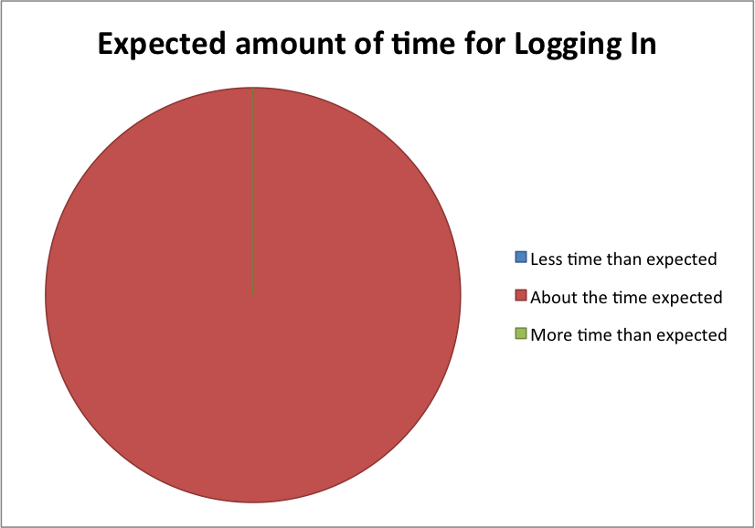

### 

#### Task A: Logging in Continued

### Comparative Ease of Use

The following chart shows the count of participants that chose each statement comparing the Lifetime Library (LL) to another application for this task. Only 3 participants had performed a similar task in Dropbox, while all 4 participants had performed a similar task in Google Drive.

|  |  |  |  |  |  |
| --- | --- | --- | --- | --- | --- |
| *LL was...* | Much Easier | Somewhat Easier | About the Same | Somewhat Harder | Much Harder |
| Dropbox |  |  | 3 |  |  |
| Google Drive |  |  | 4 |  |  |

#### Comments

*“Poor Labeling”* (referring to Log In button)

*“I’m not sure why the brand label in the top left switched from LL to iDrop...inconsistent”*

## Task B: Uploading a file

### Task Success

**100%**: 4 out of 4 participants successfully completed this task.

### System Errors

**0**: No participants received system errors while performing this task.

### Confidence and Level of Difficulty

|  |  |  |  |
| --- | --- | --- | --- |
|  | Mean | Median | Range |
| Confidence in completing task (higher is more confident) | 4.75 | 5 | 1 |
| Difficulty of task (higher is more difficult) | 1.75 | 1.5 | 1 |

### 

#### Task B: Uploading a File Continued

### Perceived Use of Time

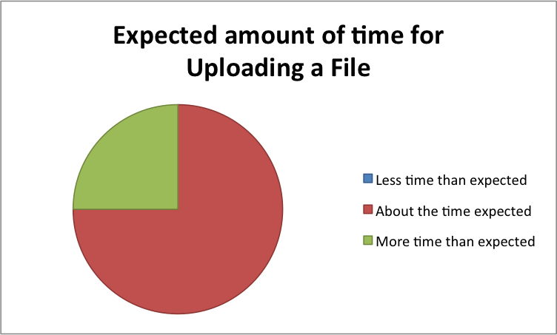

### Comparative Ease of Use

The following chart shows the count of participants that chose each statement comparing the Lifetime Library (LL) to another application for this task. Only 3 participants had performed a similar task in Dropbox, while all 4 participants had performed a similar task in Google Drive.

|  |  |  |  |  |  |
| --- | --- | --- | --- | --- | --- |
| *LL was...* | Much Easier | Somewhat Easier | About the Same | Somewhat Harder | Much Harder |
| Dropbox |  |  | 1 | 2 |  |
| Google Drive |  | 2 | 1 | 1 |  |

#### Comments

*“I say it’s harder because I can just drop files into Dropbox and Google Drive.”*

*“What makes Quick Upload different from regular upload? This is unclear.”*

## Task C: Adding metadata

### Task Success

**75%**: 3 out of 4 participants successfully completed this task. One participant gave up completing the task.

### System Errors

**3**: One participant received 3 system errors while performing the task.

#### Task C: Adding metadata Continued

### Confidence and Level of Difficulty

|  |  |  |  |
| --- | --- | --- | --- |
|  | Mean | Median | Range |
| Confidence in completing task (higher is more confident) | 3 | 3 | 4 |
| Difficulty of task (higher is more difficult) | 4.25 | 4 | 1 |

### Perceived Use of Time

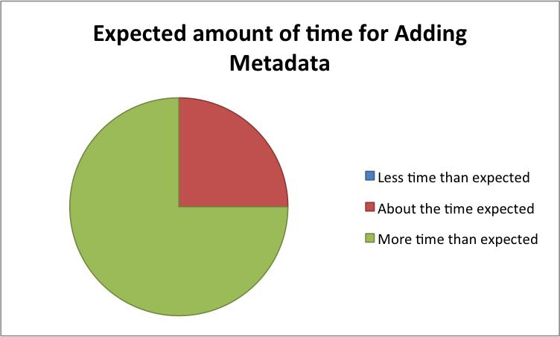

### Comparative Ease of Use

Though we collected data for comparative ease of use for this task, there are no comparable features in Dropbox or Google Drive (or other file sharing services) for adding metadata, so we cannot comment on how this feature truly compares to others.

### 

#### Task C: Adding metadata Continued

### Predicted Use

For this task, we asked an additional question to see how users predicted they may use this feature if they were regular users of the Lifetime Library.

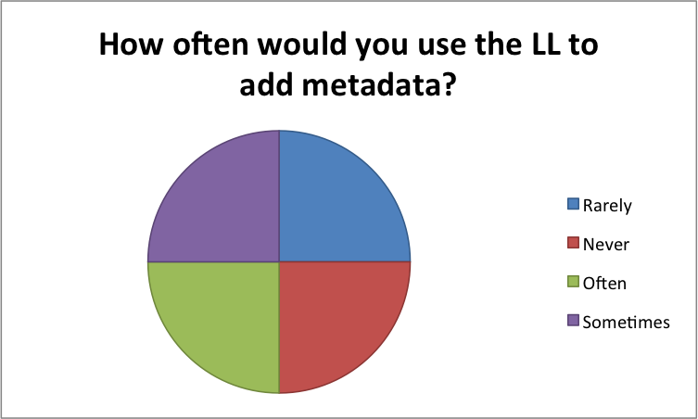

#### Comments

*“I wouldn’t care about adding metadata...”*

*“Adding metadata would depend on what I was adding.”*

## Task D: Sharing a file

### Task Success

**25%**: 1 out of 4 participants successfully completed this task. Only 1 out of the 4 participants was able to share a file with another user. To share a particular file, a user in the Lifetime Library must share the folder containing that file, rather than the file itself. Three of the participants shared the file itself, rather than the folder containing the file, so this was counted as failing to complete the task.

### System Errors

**5**: Two participants experienced 5 system errors between them.

### 

#### Task D: Sharing a file Continued

### Confidence and Level of Difficulty

|  |  |  |  |
| --- | --- | --- | --- |
|  | Mean | Median | Range |
| Confidence in completing task (higher is more confident) | 4 | 4 | 2 |
| Difficulty of task (higher is more difficult) | 4 | 4 | 2 |

**Perceived Use of Time**

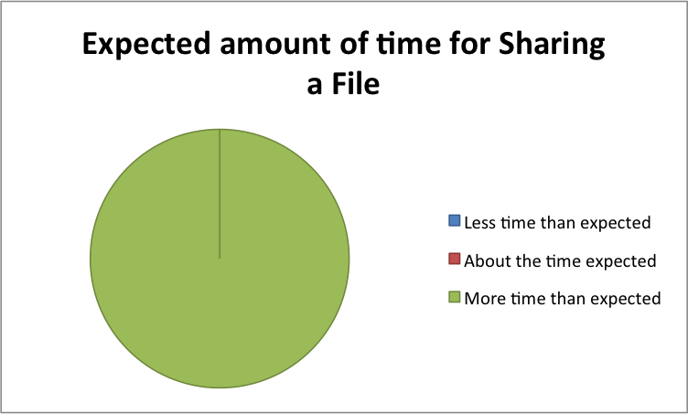

**Predicted Use**

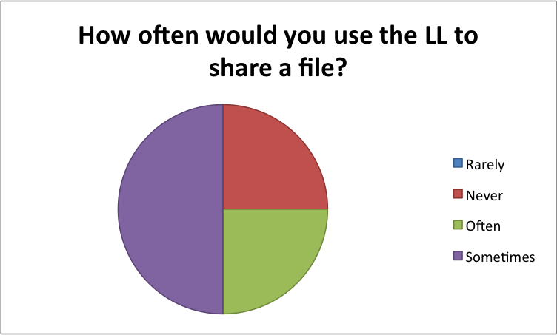

#### Task D: Sharing a file Continued

**Comparative Ease of Use**

The following chart shows the count of participants that chose each statement comparing the Lifetime Library (LL) to another application for this task. Only 3 participants had performed a similar task in Dropbox, while all 4 participants had performed a similar task in Google Drive.

|  |  |  |  |  |  |
| --- | --- | --- | --- | --- | --- |
| *LL was...* | Much Easier | Somewhat Easier | About the Same | Somewhat Harder | Much Harder |
| Dropbox |  |  |  | 1 | 2 |
| Google Drive |  |  |  | 1 | 3 |

Comments

*“The wording needs work.”*

*“Needs work on labels/terminology. What is ‘a share’?”*

*“It would depend on who else used the library. I don’t think I would publish to non-users much.”*

## Lifetime Library Usability Scale

Users filled out the Lifetime Library Usability Scale as a post-test questionnaire.

|  |  |  |  |
| --- | --- | --- | --- |
|  | Mean | Median | Range |
| LLUS Score (numbers rounded down) | 29 | 25 | 37 |

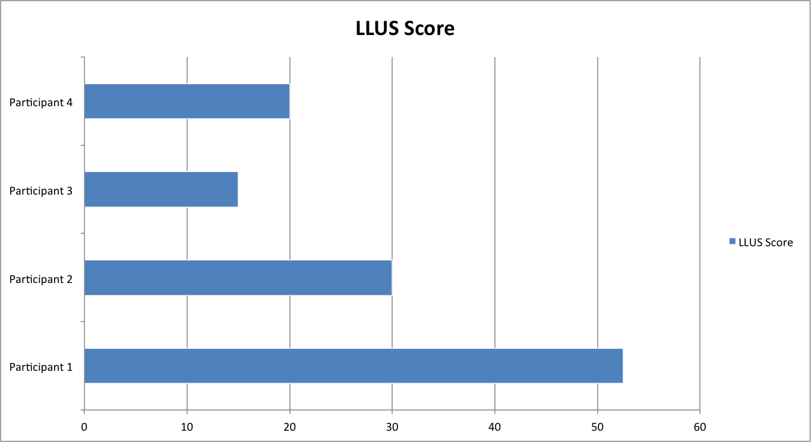

Based on research discussed at <http://www.measuringusability.com/sus>, an average score for the SUS (the basis for the LLUS), is 68. The average score from all participants is, rounded down, 29. This shows there is a lot of room for improvement for the Lifetime Library to increase its perceived ease of use among users.

## Task Totals

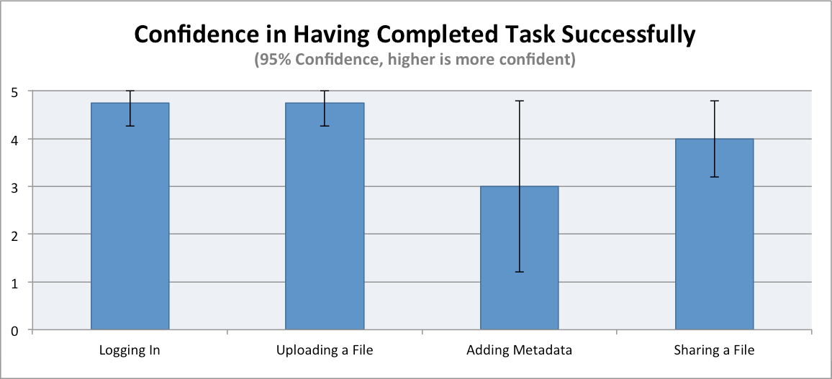

Participants only experienced problems with confidence in completing the Adding Metadata task. This may have been a result of the wording of the task or it may have been a result of the uniqueness of the attribute/value/unit concept in the Lifetime Library. More exploration of this feature is required to replicate this finding and attempt to delve further into the potential problem.

#### Task Totals Continued

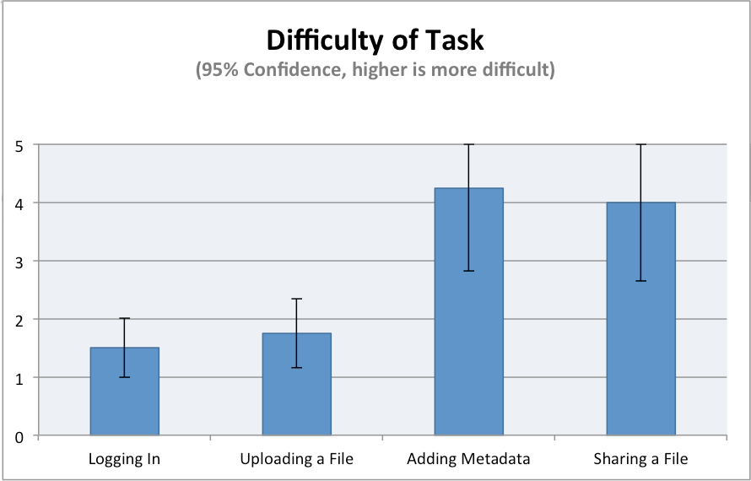

Participants perceived Adding Metadata and Sharing a File to be much more difficult than Logging In or Uploading a File. Adding Metadata and Sharing a File both averaged 4 or greater on the Likert-type scale (1 - very easy, 5 - very hard), implying participants considered these tasks “hard” in terms of difficulty. Considering how often users of such a system would use these features, some design changes should be considered (see Recommendations).

## 

## Summary of Results

Participants were mostly successful in performing all tasks we asked them to perform, with the exception of Sharing a File. However, participants were quite confident they completed the Sharing a File task. We hypothesize this is because of the way sharing works in the Lifetime Library. We asked participants to let another user view a *file*, but another user would not be able to view the file because the Lifetime Library does not support sharing *just a file*.

While the Lifetime Library does not prevent users from performing fundamental tasks (aside from sharing a file), participants perceived it as not being easy to use. The average LLUS score of 29 would translate to lower than an F, on the scale determined by [http://www.measuringusability.com](http://measuringusability.com).

# 

# Recommendations

Based on the data we collected during the evaluation, we have a few recommendations for improving the Lifetime Library. We separated our recommendations into three categories and have given each one a severity level of either high, medium, or low. High means that at least three of our four participants either did not complete the task, thought it took longer than expected, indicated confusion or negativity regarding the task. Medium means that at least two of our four participants thought it took longer than expected to complete or indicated confusion or negativity regarding the task, but all participants completed the related task successful. Low means that at least one of our four participants thought it took longer than expected to compete or indicated confusion or negativity regarding the task, but all the participants completed the related task successfully.

## Labelling

1. Update login labelling. ‘Login to iDrop Web’ to simply ‘Login’ and change ‘Please enter your credentials to log into iRODS’ to ‘Please enter your credentials to login’.

Severity: High

Although participants liked that the home page of the website clearly showed that they were using the correct site, and the green color of the login button indicated that was the correct button to press, three out of four of the participants commented on the fact that the login button was labeled ‘Login to iDrop Web’ and indicated confusion as to whether or not it would take them to the Lifetime Library. When asked to enter their credentials, one user commented that the text stated she was logging into iRODS. During the login process, users of the Lifetime Library should have no reason to question whether or not they are logging into the Lifetime Library or another system. Updating the text to remove the references to iDrop Web and iRODS will help minimize those doubts and should be a simple code change.

2. On the metadata tab, provide a description or example of what attribute, value and unit should be. Also update wording so that it is not wider than the blue background.

Severity: High

New description could read similar to the following:

“Metadata is data about data. Use this to add information about your files and folders. You may add, or select items to delete. Attribute is a named feature of the file. Value is the amount of the attribute. Unit is the measurement used for value. Attribute and value elements are required. Unit is optional.

For example, if you upload class notes and would like to keep track of which class the notes are for, you could add the following information:

Attribute - Class

Value - INLS500

Unit - <leave blank as it does not apply>”

3. Change ‘Quick Upload’ link to read ‘Upload a File.’ Also, when link is clicked, change wording from ‘Upload to iRODS’ to ‘Upload.’

Severity: Low

Having this link labelled ‘Quick Upload’ implies that it is somehow different from the regular upload process. Since it is the only link that can be used to upload from the home page, it should be labeled such that users clearly know it is a standard upload process.

## Design

1. Update sharing mechanism so that sharing can be completed in one step, individual files can also be shared, and the permissions list clearly states what each permission will do.

Severity: High

Since sharing a file actually requires sharing the folder that contains the file, only one out of four of our participants completed this task successfully, although all four recorded that they were at least somewhat confident that they had completed the task successfully. All four mentioned confusion regarding what ‘Add a share’ meant. For an important feature such as sharing, this process could be simpler.

It seemed that all of the participants assumed that individual files could be shared since that is their experience with other cloud storage services. Updating the sharing module so that individual files can be shared would help make this system more intuitive.

Also, provide a description of each of the permission roles. Although, some like ‘READ’ may seem intuitive, others, like, ‘CREATE_TOKEN’ are not. When a permission is selected, text describing what the permission does could be helpful. Updating the list of permissions to use mixed-case and spaces instead of underscores may make the list more readable.

2. Move “login” button to below password box or guest access checkbox to beside “use a guest login”.

Severity: Low

One participant commented that it was odd the login button wasn’t below the password box. This is an ascetic change to make the checkbox and the login button have a consistent look.

3. Add a message on the homepage to let users know they can scroll down for more information.

Severity: Low

Depending on the size of the browser screen, either only the main image appears or the main image appears with white space underneath it. There is no clear indication that the user can scroll down. One participant scrolled down accidentally and mentioned that she did not realize you could scroll down. Another participant commented that the tagline did not really explain to her what the Lifetime Library was and she would have liked more information. A note explaining that scrolling down is possible would allow users to determine where they can go for more information.

## System Status

1. After a file is uploaded, in addition to displaying a confirmation message, redirect user to the ‘Browse’ page, opened to the actual file in order to confirm that the file has been successfully uploaded to the system.

Severity: Medium

Half of the participants commented that the alert for successful upload was not prominent or that despite the message, they weren’t sure if the file was actually uploaded. Half of the participants commented that the list of uploaded files is not available after uploading. By redirecting the user to the browse page, the users are sure that the file was uploaded, they understand where they can go to see a list of their files, and it provides the opportunity for users to upload an additional file from that page.

2. Have more specific error messages/highlight what users need to do when adding metadata.

Severity: Low

For example, when nothing is entered, error message should read “Please enter an attribute and value” and the attribute and value entries should be highlighted in red. One of our participants tried to add either an attribute or a value and did not receive any system indication that the data was invalid because both attribute and value are required.

# 

# Reflection

In review, our evaluation goal was to measure how intuitive users found four of the features of the system: logging in, uploading a file, adding metadata to a file, and sharing a file. We believe we met our overall evaluation of measuring how intuitive users found those four specified features of the Lifetime Library. We believe the data we collected illustrates how easy users were able to use the 4 most primary functions of the website mostly due to the fact that we made participants do a think-aloud during the execution of the tasks by the participants. That data proved to be especially helpful because it assisted us in understanding the feelings of the participants while they completed the tasks, versus just having quantitative data. The post-task questionnaires also helped us achieve our goal because that data would then illustrate the participants’ feelings *after* the completion of the tasks.

One thing that did not go well happened during our very first session with a participant where we encountered the site being down, more specifically in which the user tried to login but was faced with a 404 error. Thankfully, our participant was very helpful and agreed to reschedule her session. We attempted to track down the administrator of the Lifetime Library but unfortunately he was out of town. Since the site was up, but the login interface was down, we were not sure which system (Lifetime Library or iRODS) was the culprit. After reaching out to six different people we were hoping could help us, we finally were put in contact with SILS IT support and he was able to restart the server that housed the login interface.

Another thing that we wished we could have done differently was measure difficulty and confidence in the same direction (1 to 5), in the Likert-type scale so that it would be easier for us later in the future to work with the data. And lastly, because all of us feel strongly about improving this application, we would have liked to run more participants to help better support our findings and recommendations. Not only that, but it would have the process of creating graphs easier and making our results more presentable and meaningful.

In terms of what did go well, we believe our sessions with our participants went very smoothly (with the exception of the bug we encountered mentioned above) all due to the well-prepared moderators and scribes and the fact that we had a really solid procedure checklist and moderator guide that had the right amount of detail.

# Appendix A: Moderator Guide[3]

## Pre-Session Instructions

### For Moderator:

**Before Tests**

* Reserve IISL testing room (Manning Hall room 9) for usability testing sessions
* Confirm Camtasia is working correctly
* Confirm audio recorder is working correctly
* Send email reminder to participants

“Dear {participant name}, Thank you for volunteering to be a part of our study. The study is scheduled for {day and date} at {time}. The session will be in Manning Hall, Garden Level, Room 9. If you enter Manning Hall on the Garden Level from the Lenoir side, take your first right. Someone will meet you in the large room and escort you to Room 9. Please arrive on time. Feel free to email us back if you have any questions. We look forward to working with you! Thank you, {moderator name}

* Print out 8 copies of the consent form. One for each participant to sign and one for them to take home.

**Before First Session**

* Add a favorite or bookmark for the Lifetime Library (<http://lifetime-library.ils.unc.edu/>) to IE, Firefox and Chrome
* Ensure Favorite/Bookmark bar is displayed
* Clear off desktop except for files related to the task
* Close all applications except for recording software
* Print out task sheets (two sets)
* Print out questionnaires (a set for each participant and two extra)

**Before Each Session**

* Clear browsing history, cache and cookies for each internet browser
* Ensure file required for task C is on the desktop
* Delete any files that are in the ‘test_user_eval’ Lifetime Library account

## Moderator Session Script

**Before Each Session**

Hello. My name is {moderator’s name} and I would like to thank you for coming in today. I am going to explain what we will be doing today. This is {scribe/timekeeper’s name} and {he/she} will be taking a few notes as we go through the process. I am reading from a script today to make sure that my instructions are the same to everyone who participates.

Our goal today is to collect feedback on the SILS Lifetime Library website. We will ask you to perform some tasks and ask you to think aloud as you complete them. By think aloud, we just mean to say whatever you are thinking as you work on the task. So tell us things you notice about the site, what grabs your attention, what makes you choose to click on particular links or icons, that sort of thing. If you forget to think aloud, I will remind you. We will observe how you interact with the site so we can get an idea about which parts of the site are easy to use and also which parts could use some improvement. Please remember that we are testing the site, not you, so please be completely honest with your feedback. We will appreciate your positive and negative feedback - you won’t hurt our feelings!

You do not have to participate in this study if you don’t want to. After we start, you may stop participating at any time. There will be no penalty for not participating. We will be recording the audio of our sessions and also the computer screen and movements of your mouse. The recording will only be used for the analysis of this study and we will not share or re-use it. Your personally identifiable information will not be stored with the recording.

Here is a copy of the consent form {moderator hands participant the form} stating that you agree to participate in this study and also agree to have the audio and computer screen of this session recorded. Please take all the time you need to read it over and let me know if you have any questions. I will be getting some paperwork in order while you do that. {Give participant a few minutes to read and sign.}

*{If participant refuses to sign the consent form}*

Thank you for taking the time to come here today but we cannot continue this study without a signed consent form. I’ll show you out and please feel free to contact us if you change your mind later.

*{After participant has signed the consent form, the moderator should also sign it}*

We have a copy of the consent form you just signed for you to take home if you would like. Do you have any questions before we get started? {*Clarify if participant has questions}*

Here is a brief questionnaire we would like you to fill out for some demographic and background information. Please take a few minutes to fill it out. *{Give participant the pre-test questionnaire}*

I’m going to set up the scenario for you:

“You are a student with the School of Information & Library Science (SILS) at UNC-Chapel Hill! As a privilege of being a SILS student, you are afforded the opportunity to have an account with the Lifetime Library. The Lifetime Library at UNC SILS is a website and desktop application designed to provide students with access to cloud storage. The goal of the system is to provide students and alums “trusted storage for their entire lives”, hence the name “Lifetime” Library. Today, you have decided to use it.”

As you provided consent for the session recording, I will now start recording. *{Start the Camtasia recording software.}*

This computer is equipped with Internet Explorer, Firefox and Chrome. Please open the browser of your choice and using the browser’s favorites or bookmarks, navigate to the SILS Lifetime Library.

{*If user has no previous experience*} Please provide your first reactions to this site.

**Before Each Task**

{*Give the user the task}* Here is a task I would like you to complete on the site. Please read it out loud. {*After the user has read the instructions}* Please remember to think aloud as you perform the task and let us know if you have trouble completing it.

{*After each particular task has been performed, hand the user the questionnaire to fill out}*

Please take a few minutes to fill out this questionnaire regarding the task you just worked on.

*{If the user was not able to complete the task, moderator will complete the task for the participant.}*

**During Each Task**

{*If participant stops talking during the task, gently remind her or him to think aloud. If participant struggles with the task, you may prompt her or him by asking questions or providing hints.}*

**After Test**

Now that we have completed all the tasks, please take a few minutes to fill out this questionnaire regarding the Lifetime Library.

*{Give user the Lifetime Library Usability Scale to get the user’s post tasks feedback.}*

If there is one thing that you would change about the Lifetime Library, what would it be?

Now that we have completed all the tasks, do you have any other feedback, positive or negative, that you would like to provide for the website overall?

Thank you for providing us with valuable feedback on the site and have a great day!

**Scribe Session Instructions**

The moderator will take the lead on all interactions with the user. While the moderator is interacting with the users, record the users’ thoughts about the system. While each user is testing the system and completing the think-aloud, take notes regarding the user’s reactions and statements. If you are able, also make note of user’s facial expressions. If the user says something noteworthy, but you do not get the exact quote, make a note of the time and what part of the system the user is in. The audio of the session can be used to recreate the quote during the debriefing sessions. After each session, use a copy of the post task questionnaire to document the user’s answers.

Mark users as being successful for tasks as follows:

* Logging in: user makes it to dashboard after login page
* Uploading a file: user uploads file from desktop
* Adding metadata: user adds some variation of “Camera” as attribute and “iPhone” as value with optional unit
* Sharing file: user creates a share and shares folder containing the file uploaded

For timekeeping purposes, start the clock when the user has finished reading the task and end it either when she has stated that the task is complete or when she has stated that she is giving up completing the task. Once 5 minutes has been reached, kindly state that the time for completing that task is up and have moderator stop the participant.

### Task A: Log into the SILS Lifetime Library

You are a SILS student who wants to gain access to your account with the SILS Lifetime Library. In order to do this, you need to log into the system. You want to log into the SILS Lifetime Library. Your credentials are listed below.

Please start the task as soon as you are ready and let the moderator know when you have completed the task.

username: test_user_eval

password: userevaluation

### Task B: Add a file to your account

You have a file on your computer that is from a past JOMC 690 class that you would like to add to your Lifetime Library account in order to archive it. The file you want to add is on the desktop of your computer labeled *‘oldwell.jpg’.*

Please start the task as soon as you are ready and let the moderator know when you have completed the task.

### Task C: Describe a file

Your JOMC 690 class taught you that it is important to know what kind of camera is used to take a certain picture. Therefore, you want to add some details to your file *‘oldwell.jpg’.* You want to add the information that this picture was taken with an iPhone camera, but you do not want to add it as a tag or comment.

Please start the task as soon as you are ready and let the moderator know when you have completed the task.

### Task D: Give a user permission to view, but not modify, your file.

You have a friend named ‘Jane Doe’, who is currently in the same JOMC 690 class you were in, who wants to see your file, *‘oldwell.jpg’.* You want to provide Jane Doe with permissions to view your file. Jane should not have permissions to modify your file. Jane’s username is ‘erholmes’.

Please start the task as soon as you are ready and let the moderator know when you have completed the task.

# Appendix B: Informed Consent Form[4]

University of North Carolina-Chapel Hill

Consent to Participate in a Usability Study

Adult Participants

_____________________________

IRB Study # 1-01

Consent Form Version Date: November 21st, 2013

Title of Study: Lifetime Library Usability Study

Principal Investigators: Amanda Gonzalez, Michael Head, Erin Holmes, Mrudula Sudarsanam

UNC-Chapel Hill Department: School of Information and Library Science

UNC-Chapel Hill Phone number: 919-962-9978

Email Address: mrudula@unc.edu

Study Contact email:mrudula@unc.edu

**What are some general things you should know about usability studies?**

You are being asked to take part in a usability study. To participate in this study is voluntary. You may withdraw from this study at any time without penalty. Usability studies are designed to evaluate the design of a system. You may not receive any direct benefit from being in this usability study.

Details about this study are discussed below. It is important that you understand this information so that you can make an informed choice about being in this usability study.

You will be given a copy of this consent form. You should ask the researchers named above, any questions you have about this study at any time.

**What is the purpose of this study?**

This usability study is being carried out to evaluate the Lifetime Library system. We are determining whether a user can use the lifetime library to accomplish a specific set of tasks.

**Are there any reasons you should not be in this study?**

You should not be in this study if:

* You are younger than 18 years old.
* You are not a student at UNC Chapel Hill.
* You are not fluent in speaking and writing English.

**How many people will take part in this study?**

If you decide to be in this study, you will be one of 4 people in this research study.

**How long will your part in this study last?**

You will participate in a single session that will last about an hour.

**What will happen if you take part in the study?**

In this study, you will be asks to complete as set of tasks using the Lifetime Library. As you complete the tasks, a member of the LLL group will be observing and taking notes of your interactions with the Lifetime Library. After completing each task, you will be asked to fill out some questionnaires about your experience in completing the task. Apart from that, we also will be using a screen capturing software to record your interactions with the system. We will also encourage you to ‘Think Aloud’ - a method where you voice your thoughts as you complete the task. The software used will also record audio which will help us in future review.

We will collect a variety of data during this study:

1. The screen capture software will record data about your interactions with it, including but not limited to the links that you click on.
2. Audio recording of your thoughts as you ‘Think aloud’ during the evaluation.
3. Your responses to the questionnaires will be recorded.

For any reason, you may choose not to do any task or not to answer any question that is part of the evaluation.

**What are the possible benefits from being in this study?**

Usability Studies are carried out to evaluate the design of the system so that areas of improvement can be identified and implemented. You may or may not benefit directly from this study.

**What are the possible risks or discomforts involved from being in this study?**

We believe the risks in this study to be no more than those encountered in everyday life as a student at UNC. There may be uncommon or previously unknown risks. You should report any problems to the researcher.

**How will your privacy be protected?**

We will assign an identifier to the data we collect and will not use your name. The data we collect may be stored on the computers of the members of the LLL. These computers will have encrypted hard-drives to ensure that the data is protected. Access to the experimental data will be password protected and where possible, we will use secure connections. After the analysis for this project is completed, we will delete the originally collected data and only keep aggregated data.

Participants will not be identified by name in any report or publication about this study. Although every effort will be made to keep research records private, there may be times when federal or state law requires the disclosure of such records, including personal information. This is very unlikely, but if disclosure is ever required, UNC-Chapel Hill will take steps allowable by law to protect the privacy of personal information.

Check the line that best matches your choice:

_____ OK to record my voice and screen during the study

_____ Not OK to record my voice and screen during the study

**What if you want to stop before your part in the study is complete?**

You can withdraw from this study at any time, without penalty. The investigators also have the right to stop your participation at any time. This could be because you have had an unexpected reaction, or have failed to follow instructions, or because the entire study has been stopped.

Participant’s Agreement:

I have read the information provided above. I have asked all the questions I have at this time. I meet the qualifications for the study. I voluntarily agree to participate in this research study.

_________________________________________________ _________________

Signature of Research Participant Date

_________________________________________________

Printed Name of Research Participant

_________________________________________________ _________________

Signature of Research Team Member Obtaining Consent Date

_________________________________________________

Printed Name of Research Team Member Obtaining Consent

# Appendix C: Questionnaires

## 1: Pre-Test Questionnaire

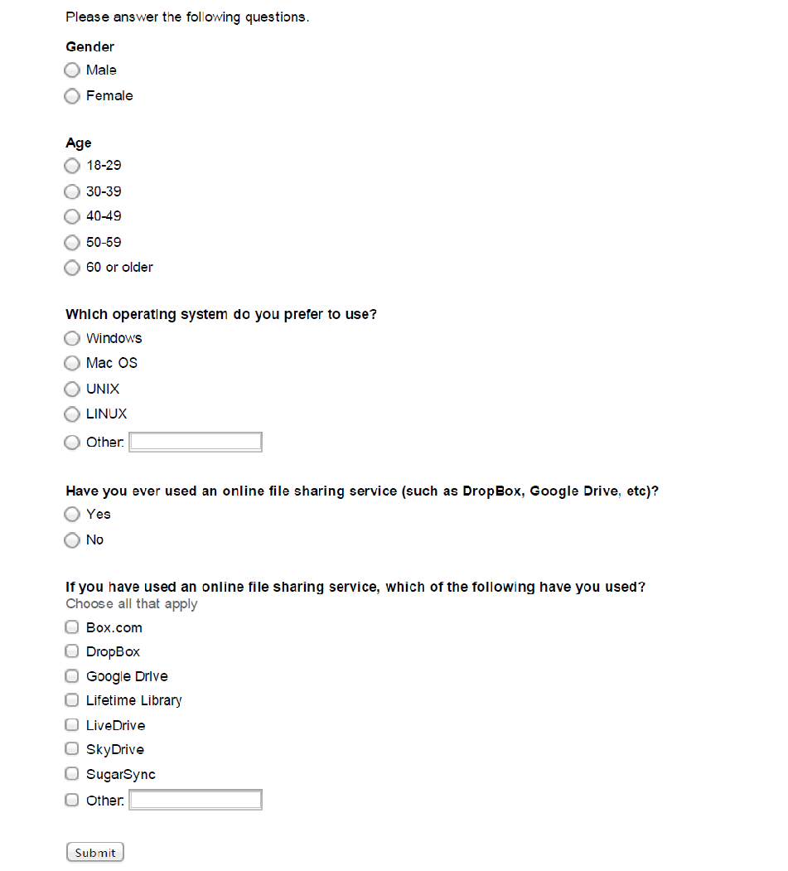

## 2: Task A Post Questionnaire

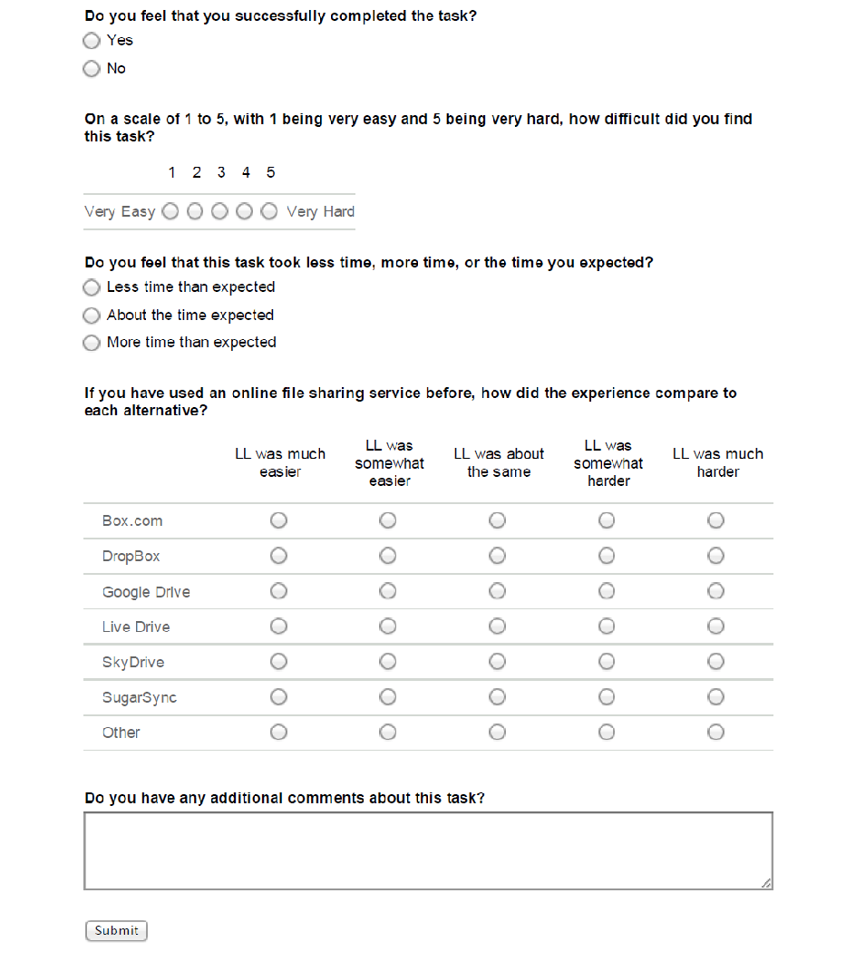

## 3: Task B Post Questionnaire

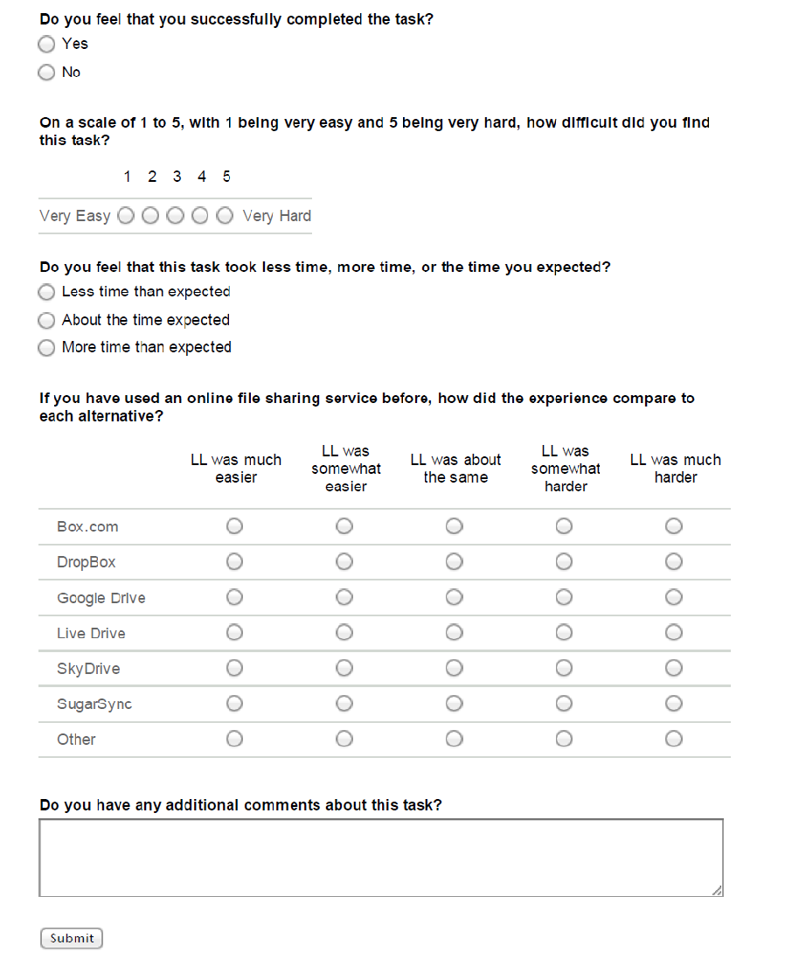

## 4: Task C Post Questionnaire

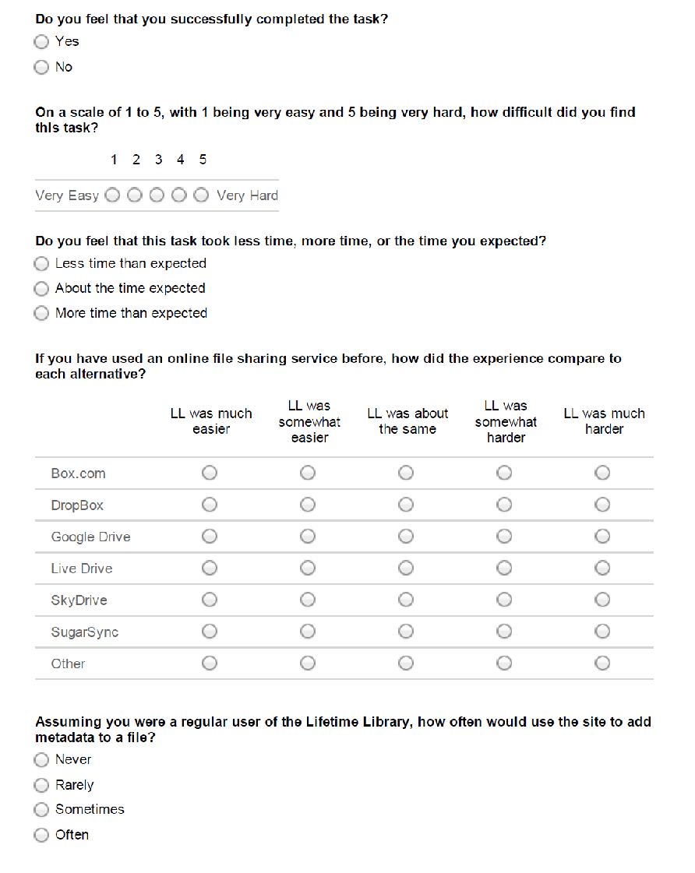

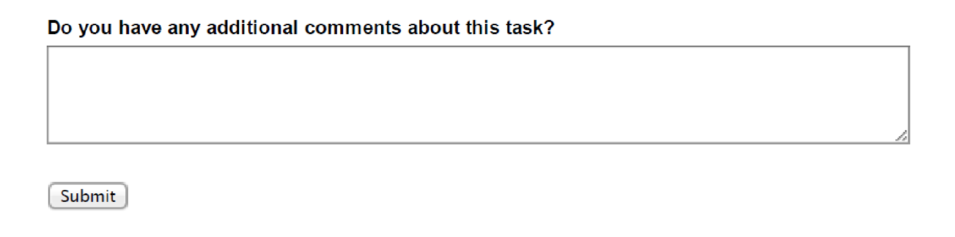

## 5: Task D Post Questionnaire

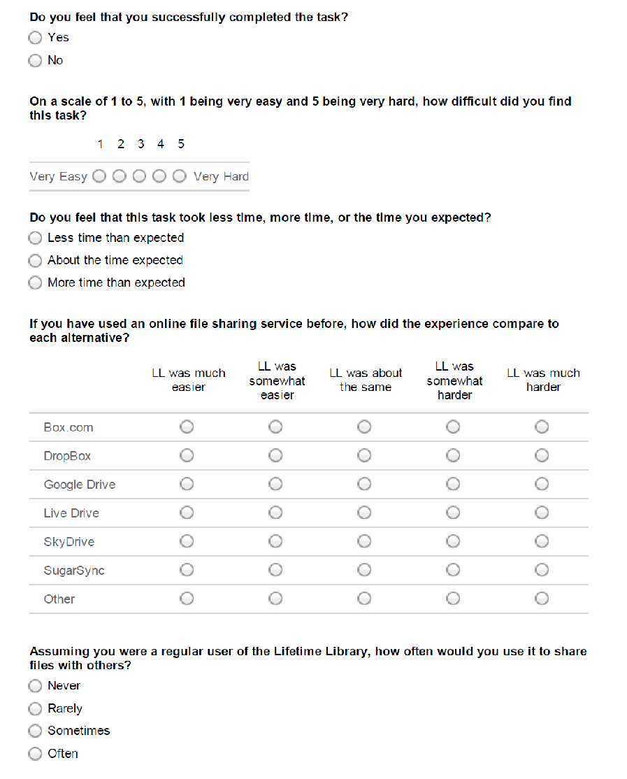

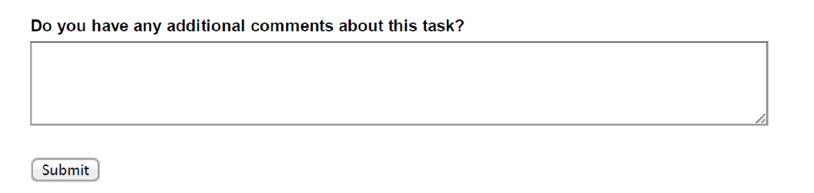

## 6: Lifetime Library Usability Scale

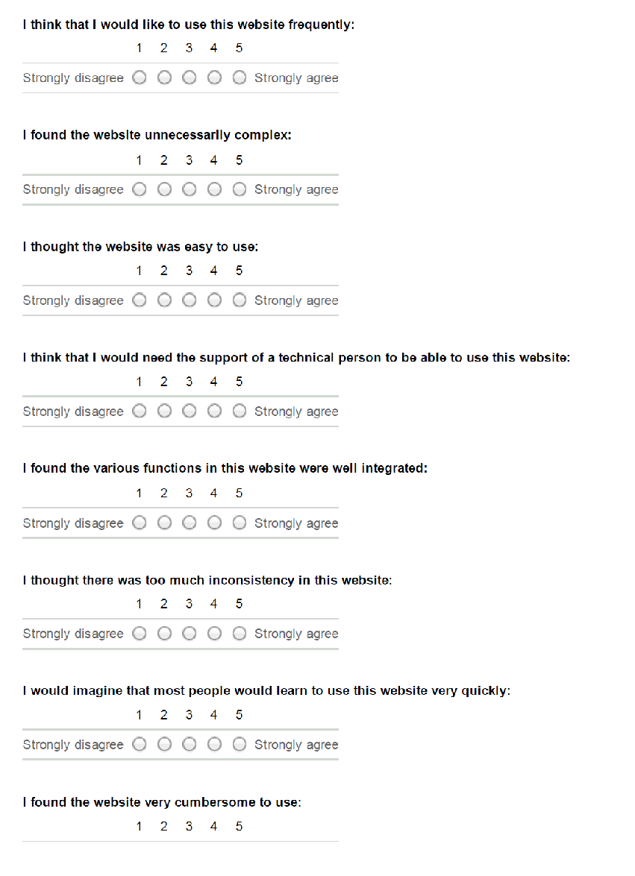

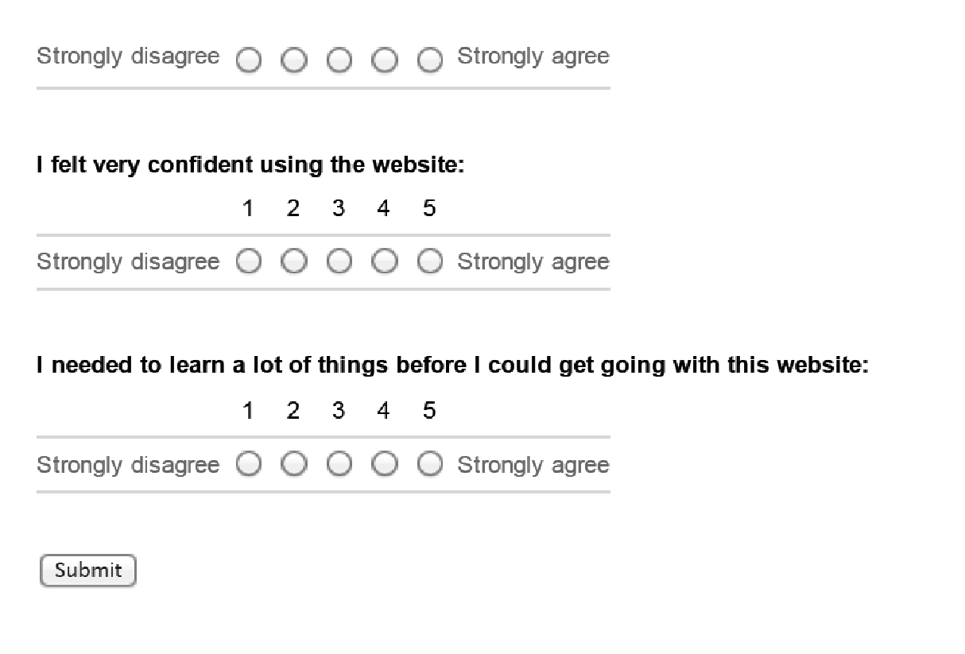

1. http://lifetime-library.ils.unc.edu/#Project-Profile-LL
2. <http://www.usability.gov/how-to-and-tools/methods/system-usability-scale.html>
3. This moderator guide was adopted from the “Health Sciences Library Virtual Presence: Usability Script” created by Anita Crescenzi. The original guide can be found on Sakai.
4. This informed consent form was adopted from the study titled “Individual Awareness of Collaborators' Activities in an Experimental Collaborative Search System” by Robert Capra. The original guide can be found on Sakai.